DAY-1

P.Bhavani

ITA0443-R PRORMMING

ASSESSMENT-1

1. PRINTTHEVERSION

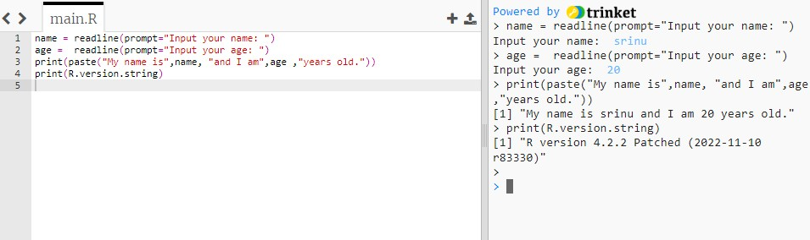

1. OBJECTINMEMORY

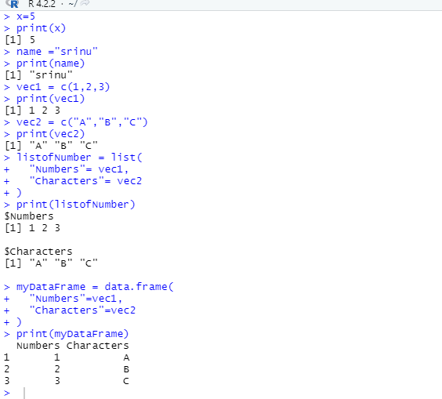

1. CREATEASEQUENCE

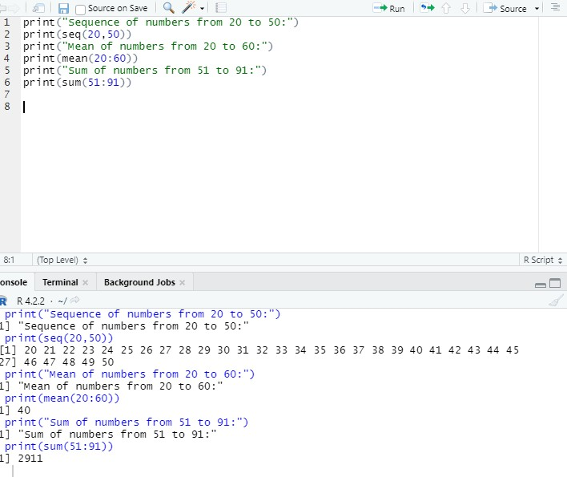

1. RANDOMINTEGERVALVES

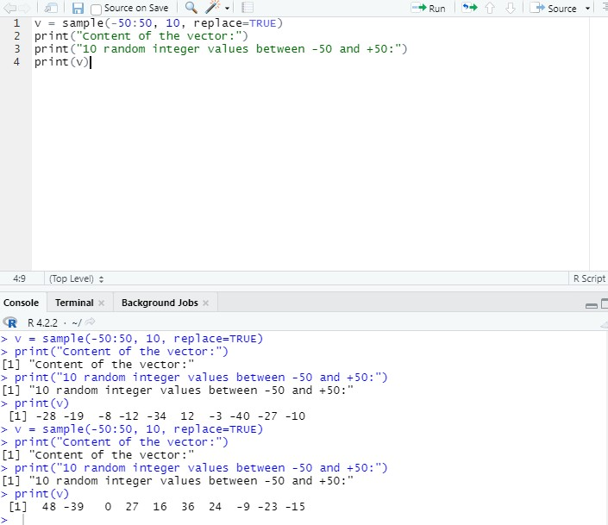

1. FIBONACCINUMBERS

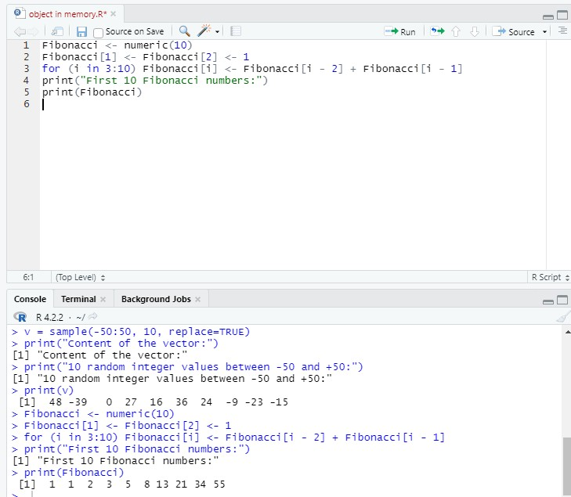

1. primenumbers

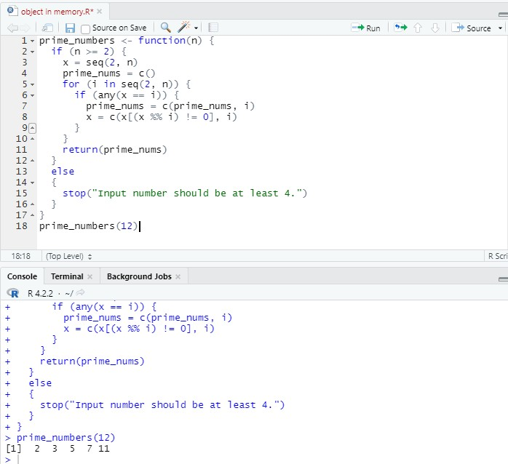

1. "fizzfor muliplesofmuliples

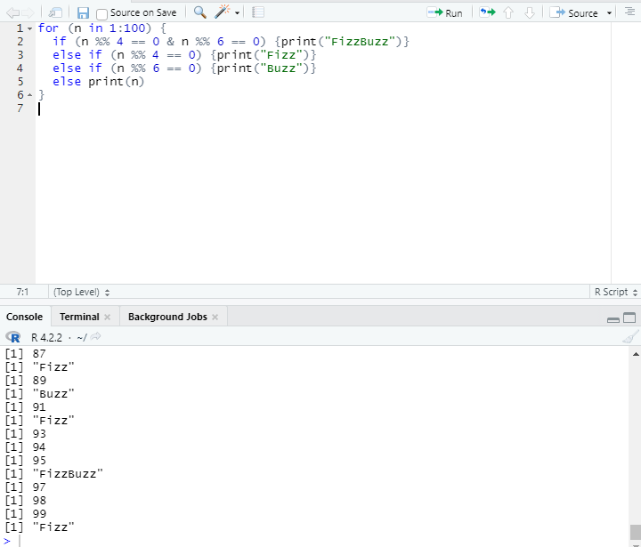

1. .RPROGAMTOPRINTTHEFRISTENGLISH

